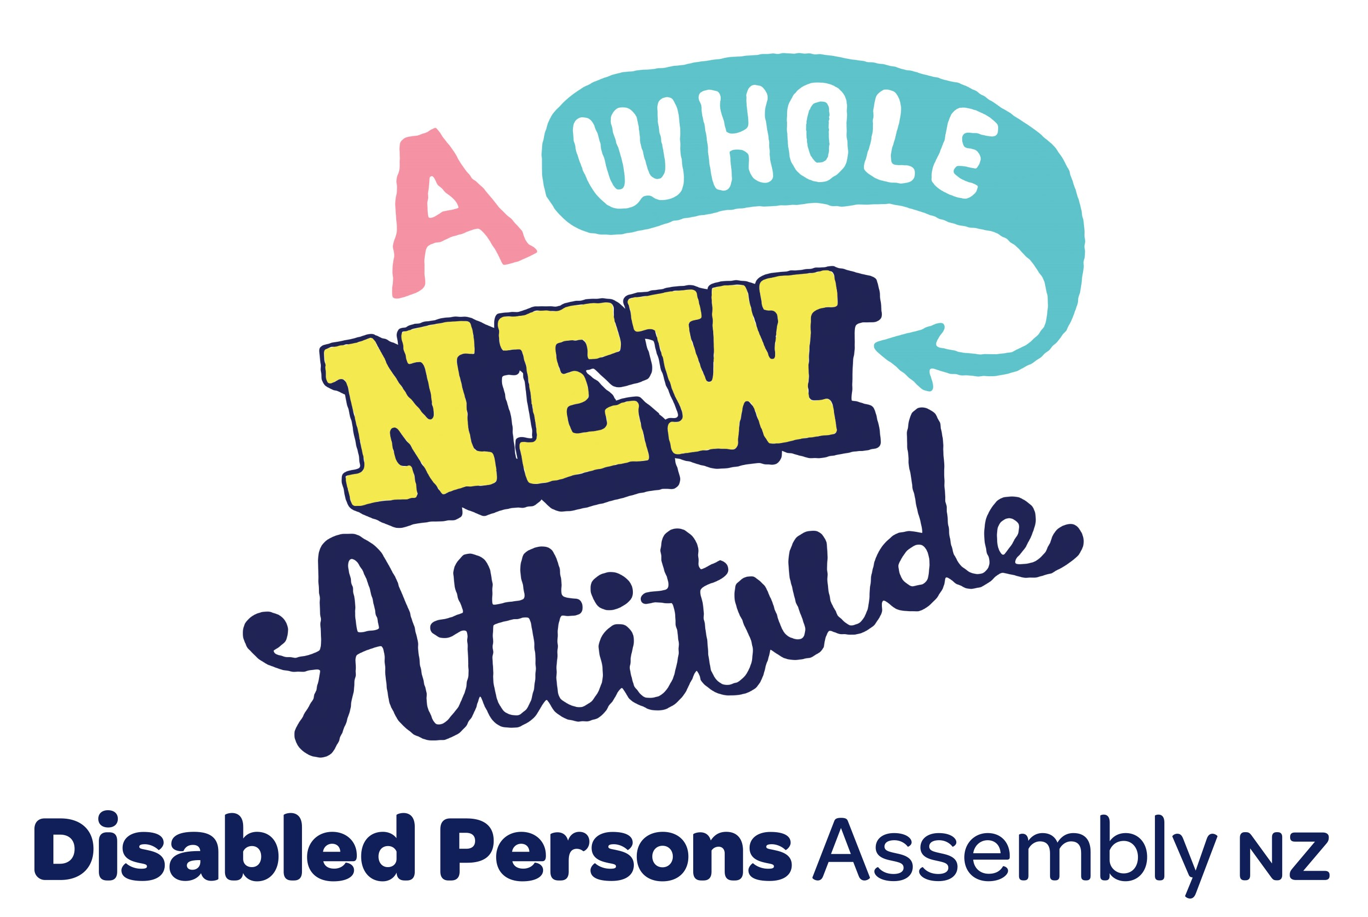
Disabled Persons Assembly NZ Inc.

Special General Meeting Minutes

18th October 2025

_______________________________________________________________________________________

Meeting Details

Date: 18th October 2025, 1pm – 2.30pm

Location: Virtual via Zoom

Present: Members: Tania Ali, Sarah Jones, Loren Glen, Jan Mortensen, Genevieve Le Bas, Anne Hawker, Jason Boberg, Ally, Raven Cretney, Louise, Christine Whittaker, Ollie Goulden, Patti Poa, Adam White, Kay Jones, EC Caucci, Eloise Fleming, Tomo Shibata. National Executive Committee: Kera Sherwood-O'Regan (Chair), Joanne Dacombe, Adriana Van Altvorst, Tara Shepherd, Juliana Carvalho, David King. Staff: Mojo Mathers, Michael Nolan, Chris Ford, Patti Poa, Sharyn McCann, Pip Townsend, Miriam O’Connor, Nikita Van Dijk. Support: Ta’ase Vaoga (Constitution Update Programme Manager - contractor), Katherine O’Brien (transcriber), Laura Cherrington (NZSL interpreter), Rosie Henley (NZSL interpreter).

Apologies: Roger Dwyer, Val Smith, Christine Haythornethwaite, Simon Atkinson.
_______________________________________________________________________________________

Minutes

Opening | At 1.00pm, Kera Sherwood-O'Regan (National President) clarified accessibility requirements were met for all participants, that we had a quorum, and then opened the meeting with a karakia.
Welcome and Housekeeping | The President gave an overview of the need for updating our constitution and outlined two additional changes in the constitution:  1. A clear process regarding distribution of our assets in the event that DPA was to be liquidated with any assets going to other NZ based DPOs or a DPO.  2. Updating one of the transition clauses to allow us to push out the date of our 2025 AGM to no later than 31 January 2026 to ensure we can re-register as an incorporated society and have sufficient time for our election process.
Proxies | It was noted that Mojo Mathers held proxies for Áine Kelly-Costello and Paul Brown, both in favour of the new constitution.
Constitution overview | Ta’ase Vaoga gave a presentation, providing an overview of the new constitution.
Question and Answer Session | The President opened the floor for any member questions about the constitution. This covered:  1. The current purpose, and whether this read more as an outcome and could be more disability focused. The President affirmed that in future we are hoping for the purpose and vision to be more explicitly disabled-led. We didn’t get the depth of engagement needed to change it in this constitution update, but this idea is reflected in the upcoming Strategy, and if that sits well with members then can also be updated in the constitution at a future AGM/SGM.  2. Increasing two-way feedback from the NEC, particularly with Regional Assemblies closing. The President confirmed that this is a priority for the NEC, and would be reflected in the forthcoming Charter and Strategy Update. NEC have also been writing key messages from meetings which will be available on the members’ section of the forthcoming website. While that's in progress, members are encouraged to email the President address with any feedback and comments for NEC.  3. Recognising the history and whakapapa of DPA as an organisation. This is important, and the team have been working to recover as much history as possible and share with incoming NEC and staff. However, the President acknowledged that capacity limitations has affected this. Members with history to share are invited to email the President, as this is very valued and NEC is hopeful this can feature on the new website.  4. Seeking clarity on the structure of governance and engagement with members. The President detailed the existing structure of the NEC, and that the only change to this in the proposed constitution is adding a Vice-President role to support, since the President role currently is too large. NEC’s mandate comes from members, so the new constitution proposes Community and Interest Groups as a way for members to connect and collaborate, and have a better channel to the NEC. The details will be worked out in the Charter.
Voting on the new constitution | At 2pm, the President confirmed the process for voting and moved:  “That the proposed constitution, as circulated on Tuesday, 14 October 2025, is adopted as the constitution of the Disabled Persons Assembly New Zealand incorporated, to take effect on the society's re-registration under the Incorporated Societies Act 2022.”  30 votes in favour. Nil abstaining. Nil opposed.  The new constitution passed unanimously.
Administration | The President confirmed that in accordance with the provision of the new constitution, the NEC members will be Kera Sherwood-O'Regan (President); Joanne Dacombe (Immediate Past President); David King; Tara Shepherd; Juliana Carvalho; and Adriana van Altvorst.  The officers will be all NEC members, plus the Chief Executive, Business Manager, Communications and Engagement Manager, and Finance Officer.  The next step will be for DPA to re-register using this new consitution.
Closing | The President thanked members, and closed with karakia at 2.30pm.

Signed……………………………………… Date……………………………………..

